CREAT A CLOUD STORAGE SERVICE

|  |  |
| --- | --- |
| **Team ID** | **PNT2022TMID40963** |
| **Project Name** | **IoT Based Smart Crop Protection System For Agriculture** |

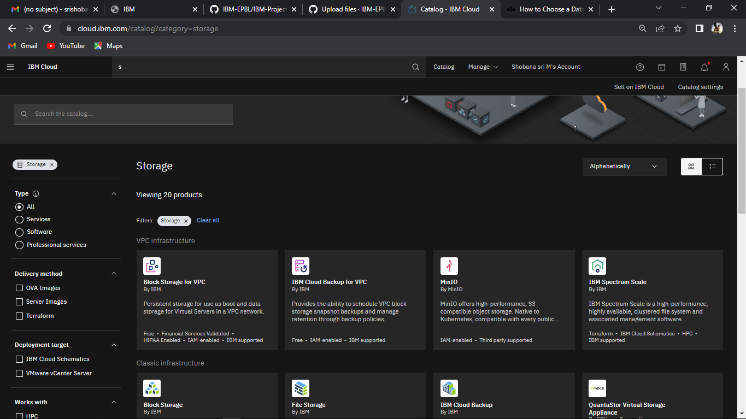

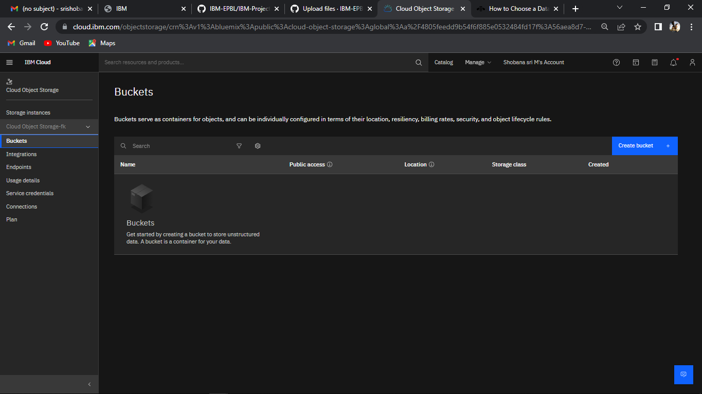

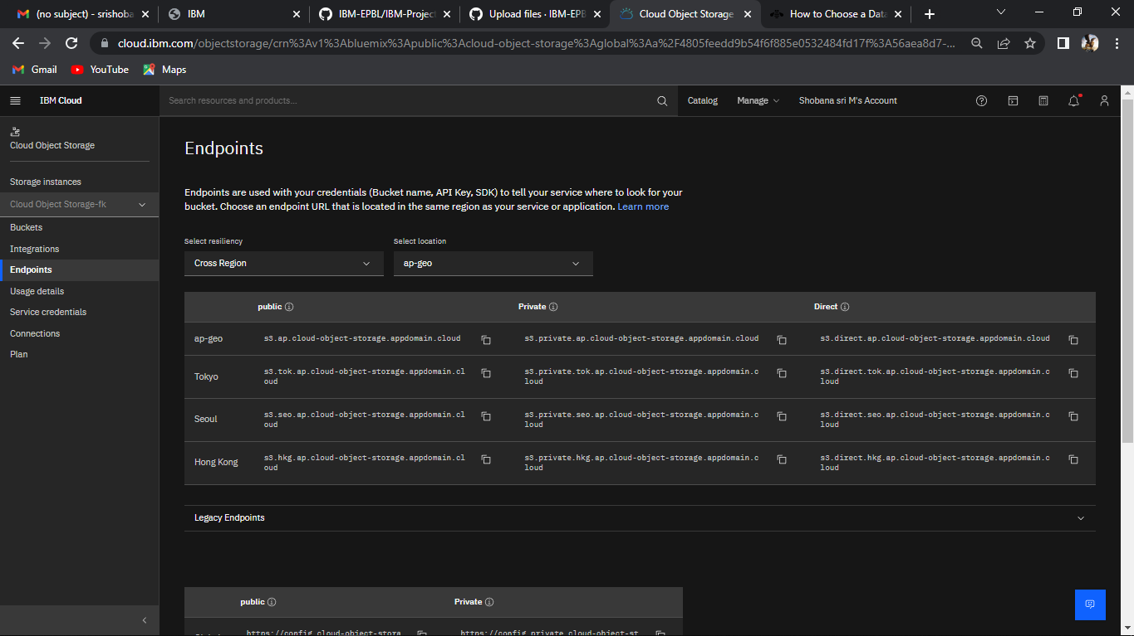

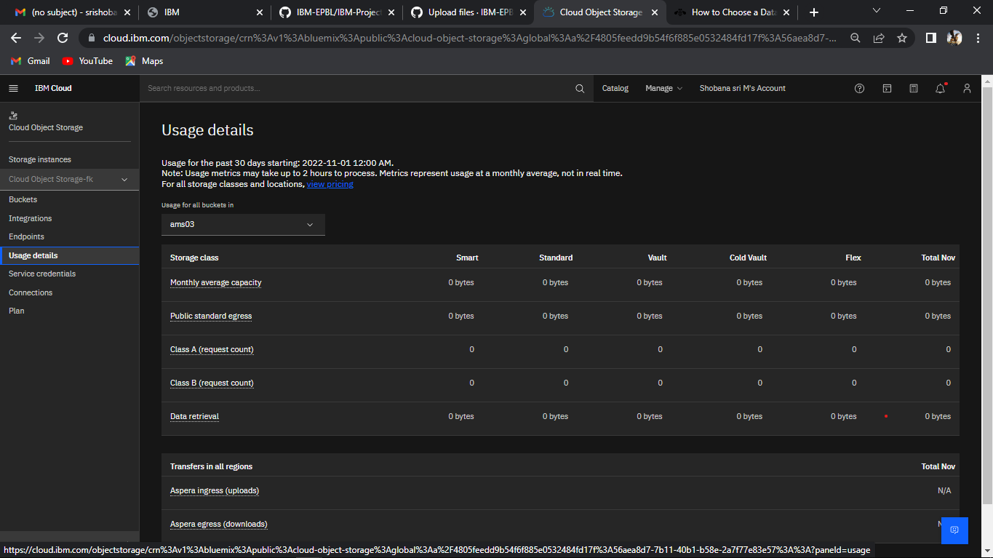

SUBMITTED BY

SHOBANA SRI .M

VEDHA PRIYA K.M.

JAYA SRI .G